## **#5: Error prevention**

Positive Findings:

* Users are notified when their own network is glitchy or if they get disconnected.

Negative Findings & Possible Improvements:

* View password option is not enabled while typing it to login to the website.

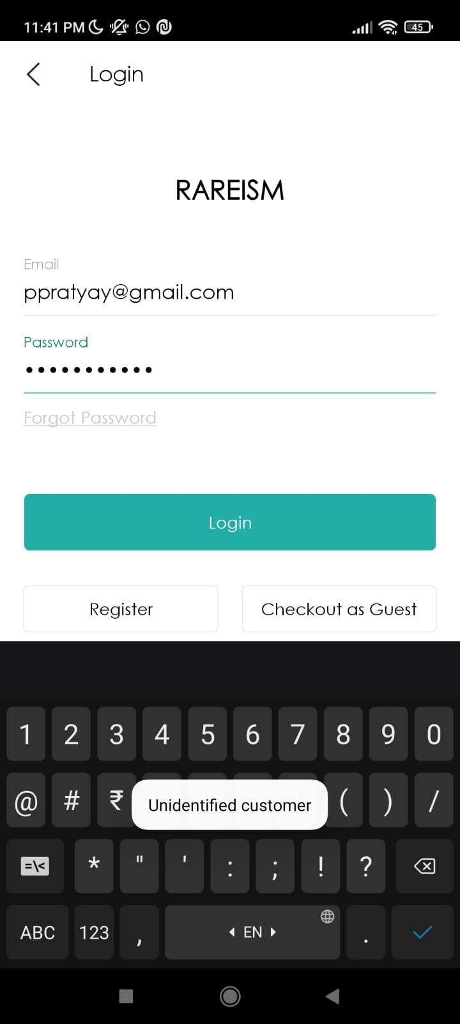

**Recommendation:** The option to view password while typing it or in case of wrong password helps user to recognise mistakes.

* The maximum quantity of order one can make is not enabled.

**Recommendation:** The maximum quantity of items one can buy would prevent error in case customer has by mistake ordered more than required number of items.

* There is no validation of the sender details like email, phone number and the pin code while updating the address.

17 **Recommendation:** The validation of correct emails, pin code and 10 digit mobile number helps in preventing error at various levels.

## **#6: Recognition rather than recall**

Positive Findings:

* Login options using email and other social media accounts is good to have things.

Negative Findings & Possible Improvements:

* There is no visible next option after adding item to cart.

**Recommendation:** It is good to prompt user to order now option to t smoothen the journey of the customer.

## **#7: Flexibility and efficiency of use**

Positive Findings:

* Login features are available through social media which saves time of user from creating new account and remembering password.

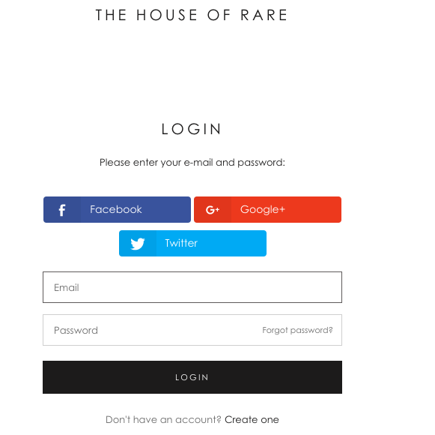

Negative Findings & Possible Improvements:

* The weekly & daily views are only vertically scrollable. That might cause new users to forget to scroll down to see their sessions. It is also a hassle & since sessions are spaced out there should be a way to

see the calendar in one view with all daily/weekly sessions. It would be good to have other layouts available based on user preference.

**Recommendation:** Explore other variants of representing sessions blocked on the calendar that a user can select. One of them would be to list daily/weeklysessions instead of spacing them out based on theirtime slots.

## **#8: Aesthetic and minimalist design**

Positive Findings:

* The colour combination used in the website draws users attention directly to the product.

Negative Findings & Possible Improvements:

* FAQ’s section is part of Return/Exchange section which takes time to find. Secondly pictures used in FAQ’s are distracting. Lastly, FAQ’s have no search option so one need to go one by one through each FAQ till you get what you were looking for.

**Recommendation:** It is always good to have FAQ’s as separate section. The aim of FAQ’s section is to provide the prompt solution of the problem. Use of text boxes in FAQ’s section should be avoided.

* The remove option from cart is not visible to the user due to overlapping colours which may confuse the users.

**Recommendation:** The colour combination of the text and cell should be changed so that it is visible to the users.

References

<https://xyuliu.com/Heuristic-Evaluation>

[https://static1.squarespace.com/static/54d7d226e4b0340f2fb9246e/t/54e015f1e4b033d521c5ac4b/14239 71825318/HeurisitcEvaluation_PaceLibrary.pdf](https://static1.squarespace.com/static/54d7d226e4b0340f2fb9246e/t/54e015f1e4b033d521c5ac4b/1423971825318/HeurisitcEvaluation_PaceLibrary.pdf)

<https://thehouseofrare.com/collections/rare-rr-and-rm>